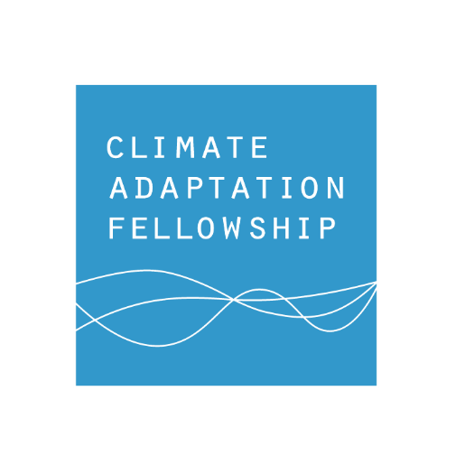
Northeast Climate Adaptation Fellows Vegetable and Fruit Program
Accepting Applications for 2021-2022
Application Deadline: October 1, 2020

Why a Climate Adaptation Fellows Program?
Climate change will lead to many challenges for vegetable and small fruit growers in the northeastern United States in the near future, including extreme rainfall, floods, droughts, and increasing pest problems.

For farmers to minimize risk to themselves and their businesses, adaptive management measures are necessary. Farmers must improve their knowledge of climate change adaptation practices relevant to their specific geographic settings and business models. These practices include growing crops better suited to new conditions, using different insurance, and exploring new business ownership structures and revenue sources such as agrotourism or consulting.

Participants in the Northeast Climate Adaptation Fellows program will enhance their knowledge of climate adaptation through a peer-to-peer curriculum. This will include resources on how to:
- mitigate on-farm greenhouse gas emissions,
- adapt management practices to changes in climate, and
- encourage other farmers to explore farm-specific climate change adaptation and mitigation measures on their own farms..

Who Should Apply?
This program is designed for commercial farmers in the Northeast U.S. who grow vegetables and/or small fruit, and agricultural advisors who work with vegetable/small fruit farms in the Northeast U.S. Fellows will complete the program in pairs (one farmer, one agricultural advisor). Interested parties can apply in pairs OR individually.

Thirty fellows will be selected to work in pairs to develop individual, personalized farm adaptation plans, as well as outreach projects such as newsletters, blog posts, fact sheets, or presentations. Some fellows also will integrate information about climate change adaptation into new or ongoing programming.

Farmers and agricultural advisors from the following states are eligible to apply: Maine, New Hampshire, Vermont, Connecticut, Massachusetts, Rhode Island, New York, Pennsylvania, New Jersey, Delaware, West Virginia, Maryland, Washington D.C.

Who has developed this program?
The fellows program is led by the University of Maine, in collaboration with the USDA Northeast Climate Hub, Rutgers University, the University of Vermont, and the Maine Organic Farmers and Gardeners Association (MOFGA). The curriculum, completed in 2019, is the result of a multiyear collaboration between multiple land grant universities, USDA agencies, nonprofit organizations and land managers. This work is supported by the National Institute of Food and Agriculture, U.S. Department of Agriculture, through the Northeast Sustainable Agriculture Research and Education program under subaward number #ENE20-164-34268, with additional support from the USDA Northeast Climate Hub.

To Apply For the Vegetable and Fruit Program Fellowship
Visit the Climate Adaptation Fellowship website adaptationfellows.net/news-2.

To learn more about the Climate Adaptation Fellows program and explore curricula for forests, dairy, and tree fruit explore the full Climate Adaptation Fellowship Website.

